Geospatial Analysis: 2nd lesson – Coordinate Reference Systems

The maps you create in this course portray the surface of the earth in two dimensions. But, as you know, the world is actually a three-dimensional globe. So we have to use a method called a map projection to render it as a flat surface.

Map projections can't be 100% accurate. Each projection distorts the surface of the Earth in some way, while retaining some useful property. For instance:

* The *equal-area* projections (like "Lambert Cylindrical Equal Area", or "Africa Albers Equal Area Conic") preserve area. This is a good choice, if you'd like to calculate the area of a country or city, for example.
* The *equidistant* projections (like "Azimuthal Equidistant projection") preserve distance. This would be a good choice for calculating flight distance.

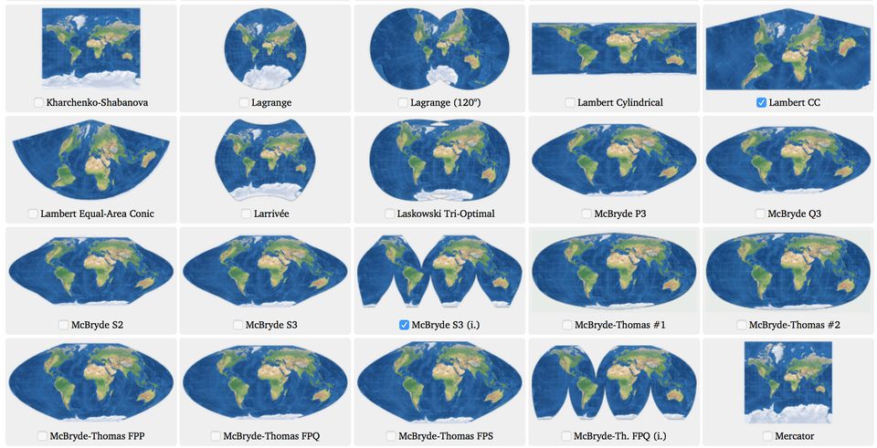

We use a coordinate reference system (CRS) to show how the projected points correspond to real locations on Earth. In this tutorial, you'll learn more about coordinate reference systems, along with how to use them in GeoPandas.

import geopandas as gpd

import pandas as pd

/opt/conda/lib/python3.7/site-packages/geopandas/_compat.py:115: UserWarning: The Shapely GEOS version (3.9.1-CAPI-1.14.2) is incompatible with the GEOS version PyGEOS was compiled with (3.10.4-CAPI-1.16.2). Conversions between both will be slow.

shapely_geos_version, geos_capi_version_string

Setting the CRS:

When we create a GeoDataFrame from a shapefile, the CRS is already imported for us.

*# Load a GeoDataFrame containing regions in Ghana*

regions = gpd.read_file("../input/geospatial-learn-course-data/ghana/ghana/Regions/Map_of_Regions_in_Ghana.shp")

print(regions.crs)

PROJCS["WGS_1984_UTM_Zone_30N",GEOGCS["WGS 84",DATUM["WGS_1984",SPHEROID["WGS 84",6378137,298.257223563,AUTHORITY["EPSG","7030"]],AUTHORITY["EPSG","6326"]],PRIMEM["Greenwich",0],UNIT["Degree",0.0174532925199433]],PROJECTION["Transverse_Mercator"],PARAMETER["latitude_of_origin",0],PARAMETER["central_meridian",-3],PARAMETER["scale_factor",0.9996],PARAMETER["false_easting",500000],PARAMETER["false_northing",0],UNIT["Meter",1],AXIS["Easting",EAST],AXIS["Northing",NORTH]]

How do you interpret that?

Coordinate reference systems are referenced by European Petroleum Survey Group (EPSG) codes. This GeoDataFrame uses EPSG 32630, which is more commonly called the "Mercator" projection. This projection preserves angles (making it useful for sea navigation) and slightly distorts area. However, when creating a GeoDataFrame from a CSV file, we have to set the CRS. EPSG 4326 corresponds to coordinates in latitude and longitude.

*# Create a DataFrame with health facilities in Ghana*

facilities_df = pd.read_csv("../input/geospatial-learn-course-data/ghana/ghana/health_facilities.csv")

*# Convert the DataFrame to a GeoDataFrame*

facilities = gpd.GeoDataFrame(facilities_df, geometry=gpd.points_from_xy(facilities_df.Longitude, facilities_df.Latitude))

*# Set the coordinate reference system (CRS) to EPSG 4326*

facilities.crs = {'init': 'epsg:4326'}

*# View the first five rows of the GeoDataFrame*

facilities.head()

/opt/conda/lib/python3.7/site-packages/pyproj/crs/crs.py:68: FutureWarning: '+init=<authority>:<code>' syntax is deprecated. '<authority>:<code>' is the preferred initialization method. When making the change, be mindful of axis order changes: https://pyproj4.github.io/pyproj/stable/gotchas.html#axis-order-changes-in-proj-6

return _prepare_from_string(" ".join(pjargs))

Region District FacilityName Type Town Ownership Latitude Longitude geometry

0 Ashanti Offinso North A.M.E Zion Clinic Clinic Afrancho CHAG 7.40801 -1.96317 POINT (-1.96317 7.40801)

1 Ashanti Bekwai Municipal Abenkyiman Clinic Clinic Anwiankwanta Private 6.46312 -1.58592 POINT (-1.58592 6.46312)

2 Ashanti Adansi North Aboabo Health Centre Health Centre Aboabo No 2 Government 6.22393 -1.34982 POINT (-1.34982 6.22393)

3 Ashanti Afigya-Kwabre Aboabogya Health Centre Health Centre Aboabogya Government 6.84177 -1.61098 POINT (-1.61098 6.84177)

4 Ashanti Kwabre Aboaso Health Centre Health Centre Aboaso Government 6.84177 -1.61098 POINT (-1.61098 6.84177)

In the code cell above, to create a GeoDataFrame from a CSV file, we needed to use both Pandas and GeoPandas:

* We begin by creating a DataFrame containing columns with latitude and longitude coordinates.
* To convert it to a GeoDataFrame, we use gpd.GeoDataFrame().
* The gpd.points_from_xy() function creates Point objects from the latitude and longitude columns.

Re-projecting:

Re-projecting refers to the process of changing the CRS. This is done in GeoPandas with the to_crs() method. When plotting multiple GeoDataFrames, it's important that they all use the same CRS. In the code cell below, we change the CRS of the facilities GeoDataFrame to match the CRS of regions before plotting it.

*# Create a map*

ax = regions.plot(figsize=(8,8), color='whitesmoke', linestyle=':', edgecolor='black')

facilities.to_crs(epsg=32630).plot(markersize=1, ax=ax)

<AxesSubplot:>

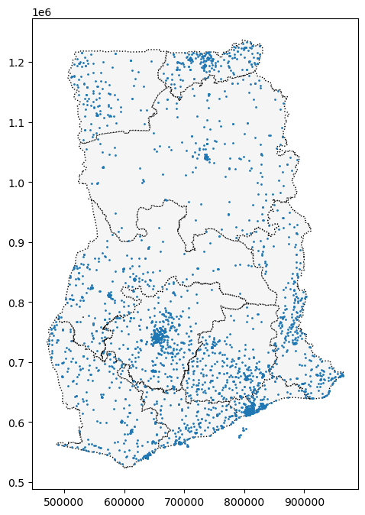

The to_crs() method modifies only the "geometry" column: all other columns are left as-is.

*# The "Latitude" and "Longitude" columns are unchanged*

facilities.to_crs(epsg=32630).head()

Region District FacilityName Type Town Ownership Latitude Longitude geometry

0 Ashanti Offinso North A.M.E Zion Clinic Clinic Afrancho CHAG 7.40801 -1.96317 POINT (614422.662 818986.851)

1 Ashanti Bekwai Municipal Abenkyiman Clinic Clinic Anwiankwanta Private 6.46312 -1.58592 POINT (656373.863 714616.547)

2 Ashanti Adansi North Aboabo Health Centre Health Centre Aboabo No 2 Government 6.22393 -1.34982 POINT (682573.395 688243.477)

3 Ashanti Afigya-Kwabre Aboabogya Health Centre Health Centre Aboabogya Government 6.84177 -1.61098 POINT (653484.490 756478.812)

4 Ashanti Kwabre Aboaso Health Centre Health Centre Aboaso Government 6.84177 -1.61098 POINT (653484.490 756478.812)

In case the EPSG code is not available in GeoPandas, we can change the CRS with what's known as the "proj4 string" of the CRS. For instance, the proj4 string to convert to latitude/longitude coordinates is as follows:

+proj=longlat +ellps=WGS84 +datum=WGS84 +no_defs

*# Change the CRS to EPSG 4326*

regions.to_crs("+proj=longlat +ellps=WGS84 +datum=WGS84 +no_defs").head()

Region geometry

0 Ashanti POLYGON ((-1.30985 7.62302, -1.30786 7.62198, ...

1 Brong Ahafo POLYGON ((-2.54567 8.76089, -2.54473 8.76071, ...

2 Central POLYGON ((-2.06723 6.29473, -2.06658 6.29420, ...

3 Eastern POLYGON ((-0.21751 7.21009, -0.21747 7.20993, ...

4 Greater Accra POLYGON ((0.23456 6.10986, 0.23484 6.10974, 0....

Attributes of geometric objects:

As you learned in the first tutorial, for an arbitrary GeoDataFrame, the type in the "geometry" column depends on what we are trying to show: for instance, we might use:

* a Point for the epicenter of an earthquake,
* a LineString for a street, or
* a Polygon to show country boundaries

All three types of geometric objects have built-in attributes that you can use to quickly analyze the dataset. For instance, you can get the x and y coordinates of a Point from the x and y attributes, respectively.

*# Get the x-coordinate of each point*

facilities.geometry.head().x

0 -1.96317

1 -1.58592

2 -1.34982

3 -1.61098

4 -1.61098

dtype: float64

And, you can get the length of a LineString from the length attribute. Or, you can get the area of a Polygon from the area attribute.

*# Calculate the area (in square meters) of each polygon in the GeoDataFrame*

regions.loc[:, "AREA"] = regions.geometry.area / 10**6

print("Area of Ghana: **{}** square kilometers".format(regions.AREA.sum()))

print("CRS:", regions.crs)

regions.head()

Area of Ghana: 239584.5760055668 square kilometers

CRS: PROJCS["WGS_1984_UTM_Zone_30N",GEOGCS["WGS 84",DATUM["WGS_1984",SPHEROID["WGS 84",6378137,298.257223563,AUTHORITY["EPSG","7030"]],AUTHORITY["EPSG","6326"]],PRIMEM["Greenwich",0],UNIT["Degree",0.0174532925199433]],PROJECTION["Transverse_Mercator"],PARAMETER["latitude_of_origin",0],PARAMETER["central_meridian",-3],PARAMETER["scale_factor",0.9996],PARAMETER["false_easting",500000],PARAMETER["false_northing",0],UNIT["Meter",1],AXIS["Easting",EAST],AXIS["Northing",NORTH]]

Region geometry AREA

0 Ashanti POLYGON ((686446.075 842986.894, 686666.193 84... 24379.017777

1 Brong Ahafo POLYGON ((549970.457 968447.094, 550073.003 96... 40098.168231

2 Central POLYGON ((603176.584 695877.238, 603248.424 69... 9665.626760

3 Eastern POLYGON ((807307.254 797910.553, 807311.908 79... 18987.625847

4 Greater Accra POLYGON ((858081.638 676424.913, 858113.115 67... 3706.511145

In the code cell above, since the CRS of the regions GeoDataFrame is set to EPSG 32630 (a "Mercator" projection), the area calculation is slightly less accurate than if we had used an equal-area projection like "Africa Albers Equal Area Conic".

But this yields the area of Ghana as approximately 239,585 square kilometers (equivalent to 92,504 square miles), which is not too far off from the correct answer.